ReactJS Hands-on 8 - Counter App Using State

Commands Used
- npx create-react-app counterapp
- cd counterapp
- npm start

Project Structure

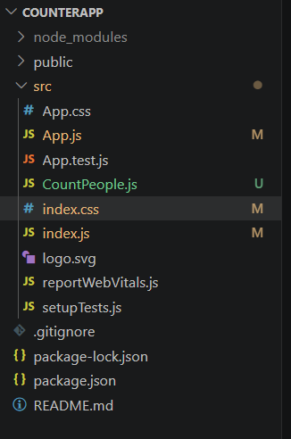

App.js
import React from "react";
import CountPeople from "./CountPeople";
function App() {
return (
<div>
<CountPeople />
</div>
);
}
export default App;

CountPeople.js
import React, { Component } from "react";
class CountPeople extends Component {
constructor() {
super();
this.state = {
entrycount: 0,
exitcount: 0
};
}
updateEntry = () => {
this.setState((prevState) => ({
entrycount: prevState.entrycount + 1
}));
};
updateExit = () => {
this.setState((prevState) => ({
exitcount: prevState.exitcount + 1
}));
};
render() {
return (
<div style={{ margin: "50px" }}>
<button onClick={this.updateEntry}>Login</button>
<span style={{ marginLeft: "10px" }}>
{this.state.entrycount} People Entered!!
</span>
<br /><br />
<button onClick={this.updateExit}>Exit</button>
<span style={{ marginLeft: "10px" }}>
{this.state.exitcount} People Left!!
</span>
</div>
);
}
}
export default CountPeople;

index.js
import React from "react";
import ReactDOM from "react-dom/client";
import "./index.css";
import App from "./App";
const root = ReactDOM.createRoot(document.getElementById("root"));
root.render(
<React.StrictMode>
<App />
</React.StrictMode>
);

index.css
body{
font-family: Arial;
}

Output
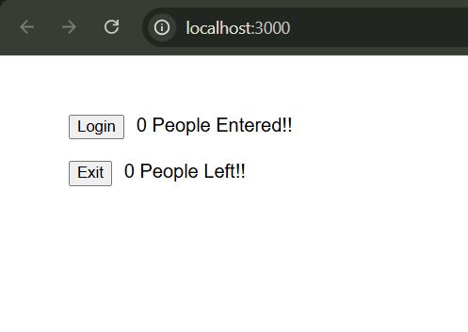
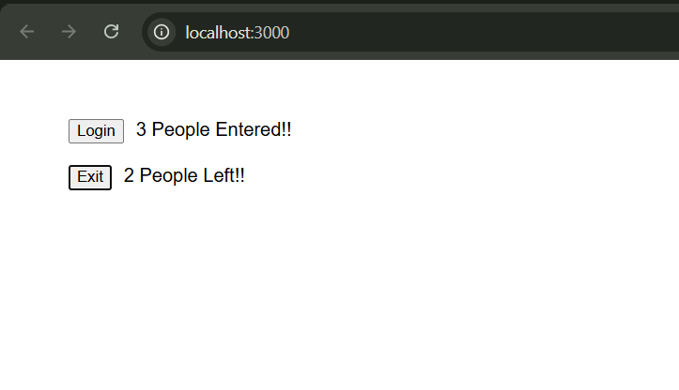

Conclusion
The Counter application was implemented successfully using a React class component, constructor, and state. The Login and Exit buttons correctly update the entry and exit counts using setState().

